|  |
| --- |
|  |
| Protractor Setup |
|  |
|  |
|  |
| 27/05/2021  1.0 |

Table of Contents

DOCUMENT PURPOSE 3

REVISION HISTORY 3

OVERVIEW 4

PREREQUISITES 4

SETUP OF PROJECT 4

DOCUMENT PURPOSE

This document will help users to understand the installation and configuration of protractor assignment.

REVISION HISTORY

|  |  |  |  |  |
| --- | --- | --- | --- | --- |
| Version(s) | Date | Status | Revised By | Comments |
| 0.1 |  | Completed |  | First Draft |
|  |  |  |  |  |
|  |  |  |  |  |
|  |  |  |  |  |

OVERVIEW

Protractor is an end-to-end test framework for Angular and AngularJS applications. Protractor runs tests against your application running in a real browser, interacting with it as a user would.

PREREQUISITES

1. Protractor should be install (Recommended 5.4.2)
2. npm should be installed (Recommended 5.3.0)
3. Webdriver-manager should be updated
4. Visual Studio Code should be installed

SETUP OF PROJECT

1. Clone the project.
2. Open the project from VS Code.
3. Run command on root folder : npm install
4. Open the new terminal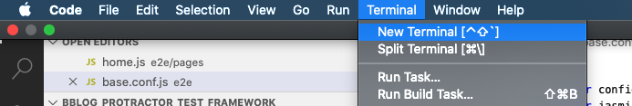
5. Run the command : webdriver-manager update
6. And run command : webdriver-manager start
7. Open new terminal and navigate to the “e2e” inside of the project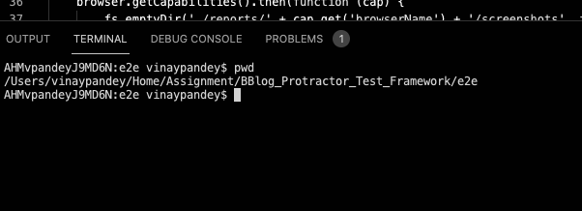
8. Run the command “protractor chrome.conf.js”

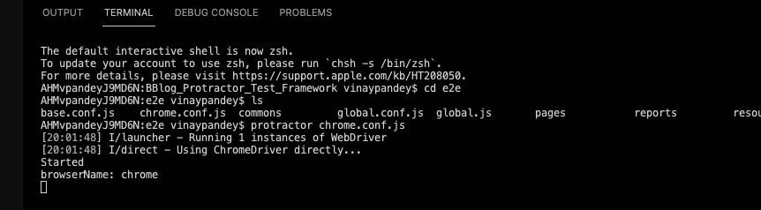

The project will start running.